**Assignment No.12**

**Roll No:-**

**Q. Write an ASP.NET Program to Perform insert & update Operation in Database using Connected Architecture.**

**Design Code:-** *(WebForm1.aspx***)**

<%@ Page Language="C#" AutoEventWireup="true" CodeBehind="WebForm1.aspx.cs" Inherits="Connected_Architecture.WebForm1" %>

<!DOCTYPE html>

<html xmlns="http://www.w3.org/1999/xhtml">

<head runat="server">

<title></title>

<style type="text/css">

.auto-style1 {

width: 100%;

}

.auto-style2 {

width: 173px;

}

</style>

</head>

<body>

<form id="form1" runat="server">

<div>

</div>

<table class="auto-style1">

<tr>

<td class="auto-style2">

<asp:Label ID="Label1" runat="server" Font-Bold="True" Text="Roll No:" Font-Size="Large"></asp:Label>

</td>

<td>

<asp:TextBox ID="TextBox1" runat="server" Font-Size="Large"></asp:TextBox>

</td>

</tr>

<tr>

<td class="auto-style2">

<asp:Label ID="Label2" runat="server" Font-Bold="True" Text="Name:" Font-Size="Large"></asp:Label>

</td>

<td>

<asp:TextBox ID="TextBox2" runat="server" Font-Size="Large"></asp:TextBox>

</td>

</tr>

<tr>

<td class="auto-style2">

<asp:Label ID="Label3" runat="server" Font-Bold="True" Text="Class:" Font-Size="Large"></asp:Label>

</td>

<td>

<asp:TextBox ID="TextBox3" runat="server" Font-Size="Large"></asp:TextBox>

</td>

</tr>

<tr>

<td class="auto-style2">

<asp:Label ID="Label4" runat="server" Font-Bold="True" Text="Mobile No:" Font-Size="Large"></asp:Label>

</td>

<td>

<asp:TextBox ID="TextBox4" runat="server" Font-Size="Large"></asp:TextBox>

</td>

</tr>

<tr>

<td class="auto-style2">

<asp:Label ID="Label5" runat="server" Font-Bold="True" Text="E-Mail ID:" Font-Size="Large"></asp:Label>

</td>

<td>

<asp:TextBox ID="TextBox5" runat="server" Font-Size="Large"></asp:TextBox>

</td>

</tr>

</table>

<asp:Button ID="btninsert" runat="server" Font-Bold="True" OnClick="Button1_Click" Text="Insert" Font-Size="Large" style="margin-bottom: 0px" />

&nbsp;<asp:Button ID="btndisplay" runat="server" Font-Bold="True" Text="Display" OnClick="Button5_Click" Font-Size="Large" Height="31px" style="margin-top: 0px; margin-bottom: 1px" />

&nbsp;

<asp:Button ID="btnupdate" runat="server" Font-Bold="True" Text="Update" OnClick="Button2_Click" Font-Size="Large" />

&nbsp;&nbsp;

<asp:Button ID="btndelete" runat="server" Font-Bold="True" Text="Delete" OnClick="Button3_Click" Font-Size="Large" />

&nbsp;&nbsp;

<asp:Button ID="btnsearch" runat="server" Font-Bold="True" Text="Search" OnClick="Button4_Click" Font-Size="Large" />

<br />

<br />

<asp:Label ID="Label6" runat="server"></asp:Label>

<br />

<asp:SqlDataSource ID="SqlDataSource1" runat="server" ConnectionString="<%$ ConnectionStrings:ConnectionString %>" SelectCommand="SELECT * FROM [Student]"></asp:SqlDataSource>

<asp:GridView ID="GridView1" runat="server" Font-Size="Large">

</asp:GridView>

</form>

</body>

</html>

**Code:-** *(WebForm1.aspx.cs*)

using System;

using System.Collections.Generic;

using System.Linq;

using System.Web;

using System.Web.UI;

using System.Web.UI.WebControls;

using System.Data;

using System.Data.SqlClient;

namespace Connected_Architecture

{

public partial class WebForm1 : System.Web.UI.Page

{

SqlConnection con = new SqlConnection(@"Data Source=(LocalDB)\v11.0;AttachDbFilename=C:\BSc.CS3\Connected Architecture\Connected Architecture\App_Data\DB1.mdf;Integrated Security=True");

SqlCommand cmd;

SqlDataReader dr;

protected void Page_Load(object sender, EventArgs e)

{

disp();

}

void disp()

{

con.Open();

SqlCommand cmd = con.CreateCommand();

cmd.CommandType = CommandType.Text;

cmd.CommandText = "select * from Student";

cmd.ExecuteNonQuery();

DataTable dt = new DataTable();

SqlDataAdapter da = new SqlDataAdapter(cmd);

da.Fill(dt);

GridView1.DataSource = dt;

GridView1.DataBind();

}

protected void Button1_Click(object sender, EventArgs e)

{

string s = "insert into Student(RollNo,Name,Class,MobileNo,EmailID) values ('" + TextBox1.Text + "','" + TextBox2.Text + "','" + TextBox3.Text + "','" + TextBox4.Text + "','" + TextBox5.Text + "')";

cmd = new SqlCommand(s, con);

cmd.CommandType = CommandType.Text;

try

{

int result = cmd.ExecuteNonQuery();

if (result > 0)

{

Label6.Text = "Student Details Has Saved..!!";

}

else

{

Label6.Text = "Failed To Save Student Details..!!";

}

catch (SqlException ex)

{

Label6.Text = ex.Message;

}

finally

{

con.Close();

}

TextBox1.Text = "";

TextBox2.Text = "";

TextBox3.Text = "";

TextBox4.Text = "";

TextBox5.Text = "";

disp();

}

protected void Button2_Click(object sender, EventArgs e)

{

string s = "update Student set RollNo='" + TextBox1.Text + "',Name='" + TextBox2.Text + "',Class='" + TextBox3.Text + "',MobileNo='" + TextBox4.Text + "',EmailID='" + TextBox5.Text + "' where RollNo='" + TextBox1.Text + "'";

cmd = new SqlCommand(s, con);

try

{

int result = cmd.ExecuteNonQuery();

if (result > 0)

{

Label6.Text = "Student Details Has Saved..!!";

}

else

{

Label6.Text = "Failed To Save Student Details..!!";

}

}

catch (SqlException ex)

{

Label6.Text = ex.Message;

}

finally

{

con.Close();

}

TextBox1.Text = "";

TextBox2.Text = "";

TextBox3.Text = "";

TextBox4.Text = "";

TextBox5.Text = "";

disp();

}

protected void Button3_Click(object sender, EventArgs e)

{

string s = ("delete from Student where RollNo='" + TextBox1.Text + "'");

cmd = new SqlCommand(s, con);

cmd.CommandType = CommandType.Text;

try

{

int result = cmd.ExecuteNonQuery();

if (result > 0)

{

Label6.Text = "Student Details Deleted..!!";

}

else

{

Label6.Text = "Failed To Delete Student Details..!!";

}

}

catch (SqlException ex)

{

Label6.Text = ex.Message;

}

finally

{

con.Close();

}

TextBox1.Text = TextBox2.Text = TextBox3.Text = TextBox4.Text = TextBox5.Text = "";

disp();

}

protected void Button4_Click(object sender, EventArgs e)

{

string s = "select * from student where RollNo = '" + TextBox1.Text + "'";

cmd = new SqlCommand(s, con);

cmd.CommandType = CommandType.Text;

try

{

dr = cmd.ExecuteReader();

if (dr.Read())

{

TextBox1.Text = dr[0].ToString();

TextBox2.Text = dr[1].ToString();

TextBox3.Text = dr[2].ToString();

TextBox4.Text = dr[3].ToString();

TextBox5.Text = dr[4].ToString();

}

else

{

Label6.Text = "No Record Found..!!";

}

dr.Close();

}

catch (SqlException ex)

{

Label6.Text = ex.Message;

}

finally

{

con.Close();

}

disp();

}

protected void Button5_Click(object sender, EventArgs e)

{

string s = "select * from student where RollNo = '" + TextBox1.Text + "'";

cmd = new SqlCommand(s, con);

cmd.CommandType = CommandType.Text;

try

{

dr = cmd.ExecuteReader();

if (dr.Read())

{

TextBox1.Text = dr[0].ToString();

TextBox2.Text = dr[1].ToString();

TextBox3.Text = dr[2].ToString();

TextBox4.Text = dr[3].ToString();

TextBox5.Text = dr[4].ToString();

}

else

{

Label6.Text = "No Record Found..!!";

}

dr.Close();

}

catch (SqlException ex)

{

Label6.Text = ex.Message;

}

finally

{

con.Close();

}

disp();

}

}

}

**\*\*\*\*\*\*\*\*\*\*\*\*\*\*\*\*\*\*\*\*\*\*OUTPUT\*\*\*\*\*\*\*\*\*\*\*\*\*\*\*\*\*\*\***

**Inserting Record:**

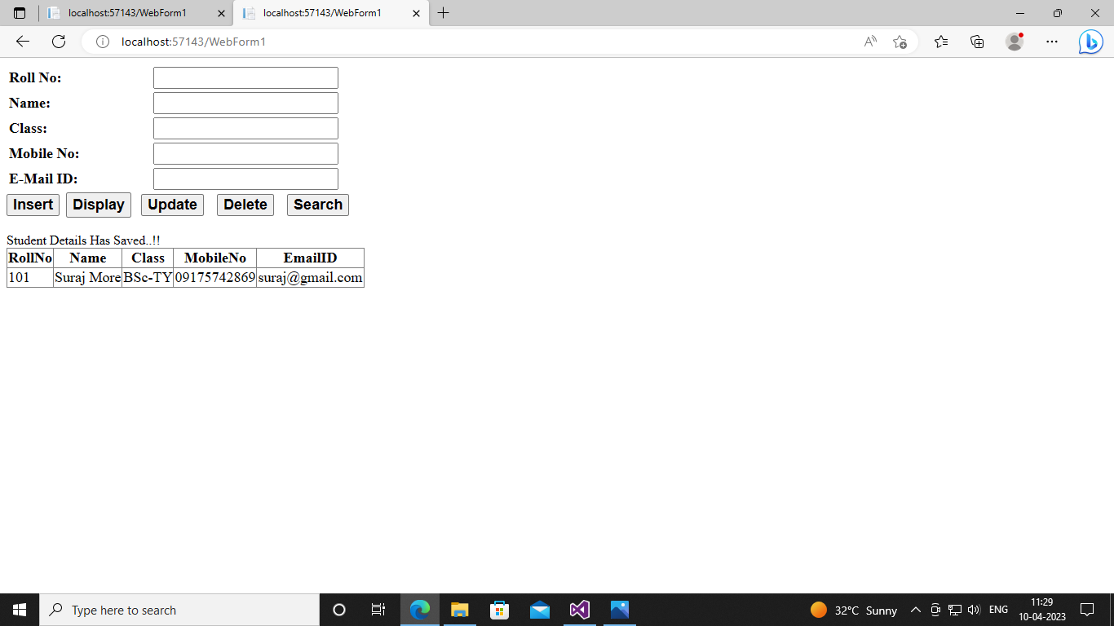

**Updating Record:**

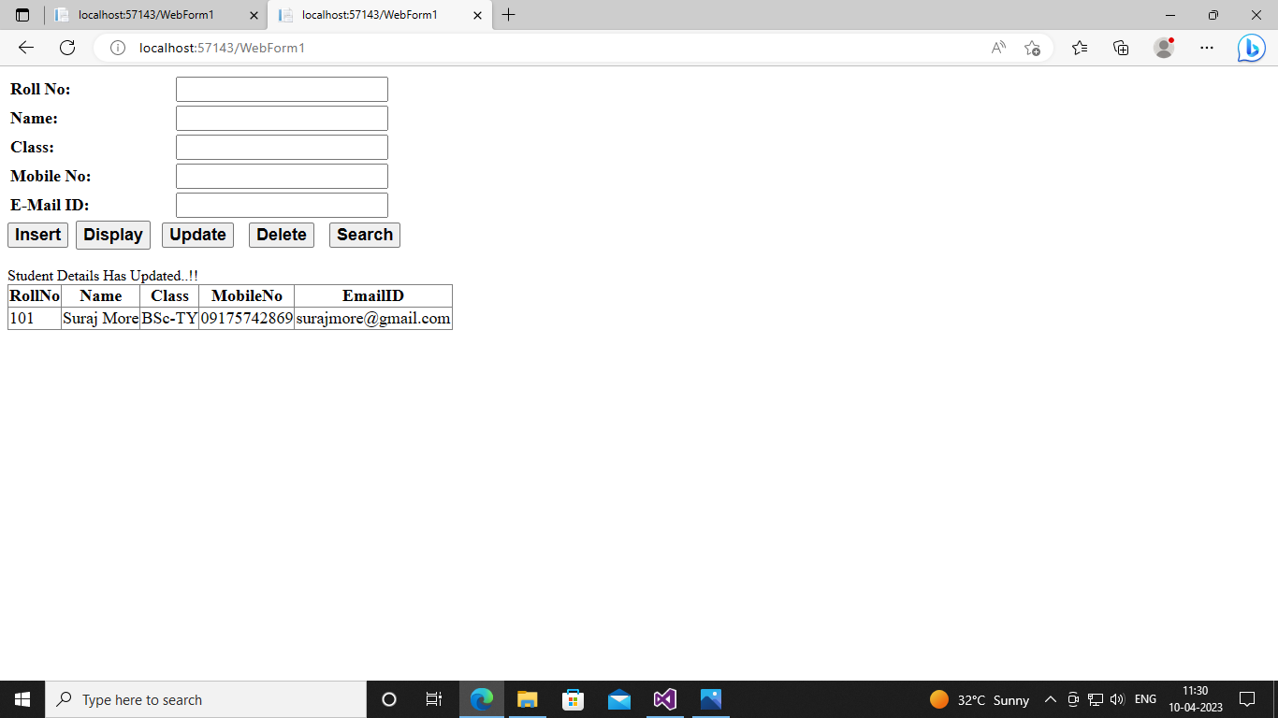

**Deleting Record:**

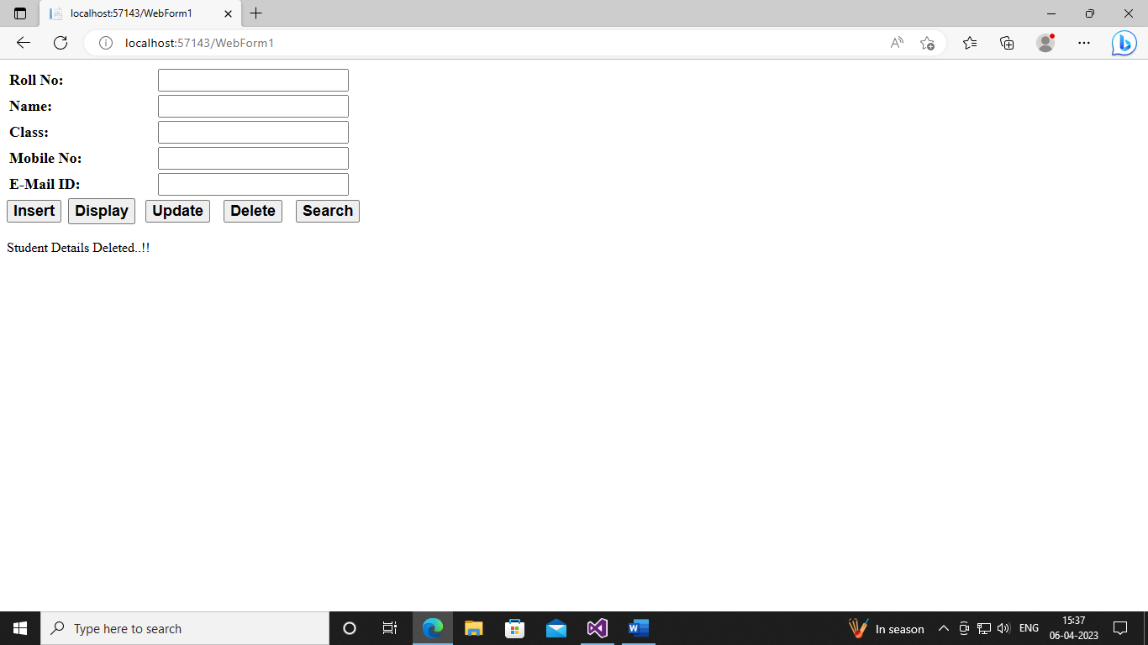

**Searching Record 101 From Records:**

